CV Application Form  Name & Surname  RANK: DOCTOR/ MEDICAL OFFICER  DATE: 30 October 2019 | 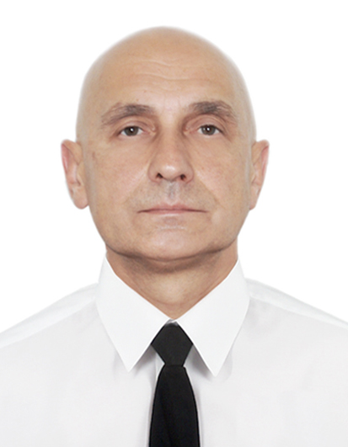  PHOTO

Main info
Name / Surname: | Vasyl Sirenko
Position applied for: | Doctor /Medical Officer/Medical Staff | Desired Vessel Type: | Passenger/Cruise Vessel /Ferry/ Offshore industry
Minimum salary $: | 3000 | Birthday / Placeofbirth: | 27 Aug.1968 ; Talne ; Tcherkasska Region UKRAINE
Phones: | +38 097 518 24 89  +38 067 724 72 59 | Citizenship: | Ukraine
E-mail: | vasiliyseadoc97@yahoo.com | Country ofresidence / City: | Ukraine/Odesa
Skype: | yoshimura1655 | Home address: | 74-Pedagogytchna 16a 65000 Odesa UKRAINE
English level: | advanced | Closest airport: | Odesa
Married: | negative | Children: | negative

Biometrics
Sex: Male | Height(cm): 175 | Overall size: 48-50
Eyes color: gray | Weight (kg): 70 | Shoe size: 42

Additional info
Maritime education: | MEDICAL | Additional skills:
Specialty: | Physician | Knowledge ofother  languages: | French ;German

Next of Kin
Next of kin: | Sister | Kin phone: | +300486839131
Kin name, Surname: | Tetjana Sirenko | Kin address: | 27Prospekt Mira 39 Tchernomorsk Odesska Ukraine

Medical certificates
Title of document | Date of issue | Country of issue | Valid up
Yellow Fever | 01 Dec2007 | Ukraine | Lifelong
Last medical examination | 7 October2019 | UKRAINE | 7 October 2021

Passports / Certificates / Documents / Licenses
Title of document |  |  |  | No. |  | Date of issue |  | Country of issue | Valid up
Seaman's book |  |  |  | AB547811 |  | 26Febr2015 |  | Ukraine | Prolongation till 21 Nov2024
International passport |  |  |  | FB004670 |  | 27 Jan2015 |  | Ukraine | 21 Jan2025
US VISA |  |  |  | P0456227
Schengen VISA
 |  | Rank | DOCTOR / Medical Officer
Professional license  Medical University Graduation Diploma |  |  |  |  | KB799494 |  | 30.06.1990 | Ukraine |  | permanent
Endorsement (Ships Doctor Certificate) |  |  |  |  | 0006/2004 |  | 14.05.2004 | Ukraine |  | permanent
Certificate of competency Ships Doctor Licence |  |  |  |  | 0002/2019 |  | 09.10.2019 | Ukraine |  | permanent
Basic Safety Training and Instructions |  |  |  |  | 03748 |  | 04.03.2019 | Ukraine |  | 04.03.24
Advanced FireFighting |  |  |  |  | 03748 |  | 04.03.2019 | Ukraine |  | 04.03.24
Proficiency in SurvivalCraft and RB |  |  |  |  | 02483 |  | 04.03.2019 | Ukraine |  | 04.03.24
Security-related training instruction for all seafarers |  |  |  |  | 22742 |  | 15.01.19 | Ukraine |  | 15.01.24
Ship Security Officer
Designated security duties of shipboard personnel
ECDIS
Radar Management(ARPA+Radar)
Medical First Aid |  |  |  |  | 03748 |  | 04.03.2019 | Ukraine |  | 04.03.24
Medical Care
GMDSS Operator
GMDSS Endorsement
Ship Carrying Danger/hazard Cargo
Bridge ResourceManagement
Ship handling arrangements:
Security training for seafarers with designated security duties |  |  |  |  | 01958 |  | 04.03.19 | Ukraine |  | 04.03.24
Other Documents / Certificates_  ACLS(AHA) |  |  |  |  | ZZ20747 |  | Jan2020 | Krakow(Poland) |  | Jan2022
Other Documents / Certificates  ALS (EU) |  |  |  |  | ERC-113-442369 |  | June2018 | Krakow(Poland) |  | 09/07/2021
Other Documents / Certificates  PALS(AHA) |  |  |  |  | ZZ20747 |  | July 2018 | Krakow(Poland) |  | July 2020
Other Documents / Certificates  ITLS |  |  |  |  | 34486 |  | Nov2018 | Krakow(Poland) |  | Nov2021
Other Documents / Certificates
Other Documents / Certificates
Other Documents / Certificates
Other Documents / Certificates

Sea service (last 5 years)
Position | Vessel Name / Flag | Vessel type / GRT | ME Type / kW | From - Till | Shipowner
DOCTOR | Victory 1( Bahamas) | Passenger/ |  | Oct2019-Nov 2019 | Victory Holding/CMI
DOCTOR | Paul Gauguin | Passenger/ 19.170 | 4500 | March2019-June2019 | Paul Gauguin Cruises
DOCTOR | Paul Gauguin | Passenger/ 19.170 | 4500 | Octr2017-Jan2018 | PG Cruises
DOCTOR | Paul Gauguin | Passenger/  19.170 | 4500 | Febr2017-May2017 | PG Cruises
Doctor | Tere Moana | Passenger |  | Oct2015-May2016 | PG Cruises
Doctor | FTI BERLIN | Passenger  9 570 |  | Febr2015-Aug2015 | FTI Cruises
Doctor | Thompson Majesty | Passenger |  | Apr.2014-Jan.2015 | Thompson Cruises

