SEAFARER'S APPLICATION FORM  Position: THIRD OFFICER or JUNIOR OFFICER Readiness: 10.12.2020  Citizenship: Russia  Last name: Zenkin Marital status single  First name: Aleksei Children:  Middle name: Yurievich Nationality: Russian  Birth date: [date-of-birth] Birth place: Russia  Home address: [home-address]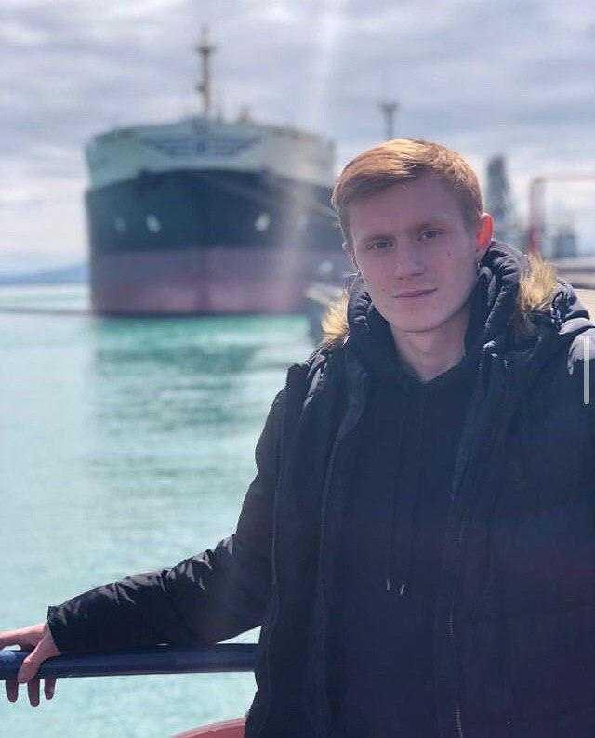

Salary | Minimum: 1000 |  | Expected: 2500 |  |  |  |  |  | Last: 1500 |  |  |  |  |  | $/month
Education
Educational institution | Speciality |  | Faculty |  | Place |  |  |  | Number |  |  |  | From |  |  |  | Till
“State Maritime University named of admiral F.F. Ushakova" | Navigator |  | Navigation Bridge officer |  | Novorossiysk/RUS |  |  |  | 1023180076633 0280 |  |  |  | 01.09.2015 |  |  |  | 29.06.2019
Passports, Licenses & Certificates
Title |  |  |  |  | Number |  |  |  | Place of issue |  |  |  |  | Issued |  |  |  | Valid
Passports & Visas
Civil passport |  |  |  |  | 0312221341 |  |  |  | Sochi, RUS |  |  |  |  | 13.05.2013 |  |  |  | 01.01.2100
Seaman's book |  |  |  |  | 0270596 |  |  |  | Novorossiysk, RUS |  |  |  |  | 20.06.2017 |  |  |  | 01.01.2100
Travel passport |  |  |  |  | 754408329 |  |  |  | Sochi, RUS |  |  |  |  | 03.03.2017 |  |  |  | 03.03.2027
Seafarer`s identity document |  |  |  |  | 0361874 |  |  |  | Novorossiysk, RUS |  |  |  |  | 05.06.2017 |  |  |  | 04.06.2022
Liberia Maritime Authority |  |  |  |  | 1377955 |  |  |  | Virginia, USA |  |  |  |  | 19.01.2018 |  |  |  | 19.01.2023
Diplomas & Endorsements
Diploma |  |  |  |  | 102318 0076633 |  |  |  | Novorossiysk, RUS |  |  |  |  | 29.06.2019 |  |  |  | 01.01.2100
Certificate of Competency |  |  |  |  | NVS203749660 |  |  |  | Novorossiysk, RUS |  |  |  |  | 07.10.2019 |  |  |  | 12.01.2022
Certificate for Operators of small craft |  |  |  |  | AD443839 |  |  |  | Sochi, RUS |  |  |  |  | 22.08.2019 |  |  |  | 22.08.2029
GMDSS Restricted Operator Certificate |  |  |  |  | ROC-025/17 |  |  |  | Novorossiysk, RUS |  |  |  |  | 21.11.2018 |  |  |  | 12.01.2022
Certificates & Licenses
Medical First Aid (VI/4.1) |  |  |  |  | 0467799 |  |  |  | Novorossiysk, RUS |  |  |  |  | 12.01.2017 |  |  |  | 12.01.2022
Basic Safety Training (VI/1.1-4) |  |  |  |  | 0567575 |  |  |  | Novorossiysk, RUS |  |  |  |  | 12.05.2017 |  |  |  | 12.05.2022
Security-related training for all seafarers (Section A-VI/6,table A-VI/6-2) |  |  |  |  | 0759761 |  |  |  | Novorossiysk, RUS |  |  |  |  | 26.05.2017 |  |  |  | 26.05.2022
Operational use of electronic chart display and information systems (ECDIS) |  |  |  |  | 1212646 |  |  |  | Novorossiysk, RUS |  |  |  |  | 25.01.2019 |  |  |  | 25.01.2024
operational use of automatic radar plotting aids (ARPA) |  |  |  |  | 1003016 |  |  |  | Novorossiysk, RUS |  |  |  |  | 12.04.2019 |  |  |  | 12.04.2024
Radar observation and plotting |  |  |  |  | 1002589 |  |  |  | Novorossiysk, RUS |  |  |  |  | 12.04.2019 |  |  |  | 12.04.2024
Proficiency in survival craft and rescue boats other than rescue boats |  |  |  |  | 1091012133 |  |  |  | Novorossiysk, RUS |  |  |  |  | 23.01.2019 |  |  |  | 23.01.2024
Advanced fire fighting |  |  |  |  | 2181012131 |  |  |  | Novorossiysk, RUS |  |  |  |  | 21.12.2018 |  |  |  | 21.12.2023
Basic training for oil and chemical tanker cargo operations |  |  |  |  | 2102042873 |  |  |  | Novorossiysk, RUS |  |  |  |  | 18.12.2020 |  |  |  | 18.12.2025
Sea-going experience
№ | Vessel’s  name | Flag |  | Type |  |  | Engine |  |  | Rank |  | From |  |  |  | Shipowner
 |  | Year |  | DWT |  |  | HP |  |  |  |  | Till |  |  |  | Crew Agency
1 | Montego Bay | RUS |  | Yacht |  |  | Cummins |  |  | Master |  | 25.11.2020 |  |  |  | Rosmorport
 |  | 2003 |  |  |  |  | 710 |  |  |  |  | 09.12.2020
2 | Ariadna | RUS |  | Sailing ship |  |  | Volvo |  |  | Master |  | 10.07.2019 |  |  |  | Rosmorport
 |  | 1999 |  |  |  |  | 61 |  |  |  |  | 15.10.2019
3 | RVK Vodolaz kuzminih | RUS |  | Special Purpose Ship |  |  | B&W |  |  | Deck Cadet |  | 10.01.2019 |  |  |  | FBU "Rosspasslugba"
 |  | 2018 |  | 142 |  |  | 5996 |  |  |  |  | 03.06.2019
4 | KALUGA | LBR |  | Crude oil tanker |  |  | B&W |  |  | Deck Cadet |  | 27.01.2018 |  |  |  | SOVKOMFLOT
 |  | 2003 |  | 115000 |  |  | 21490 |  |  |  |  | 13.08.2018
5 | Khersones | RUS |  | Sailing ship |  |  | Sulzer |  |  | Deck Cadet |  | 30.06.2017 |  |  |  | Rosmorport
 |  | 1989 |  | 2284 |  |  | 750 |  |  |  |  | 31.08.2017
General Physical State
Height (cm) | Weight (kg) |  |  |  |  | Shoes |  | Clothes |  |  | Hair color |  |  |  |  | Eye color
178 | 70 |  |  |  |  | 42 |  | M |  |  | red |  |  |  |  | blue

Additional information
My name is Zenkin Aleksei, I am 21 years old and I have a lot of maritime experience despite my young age, both in the merchant vessels and on small ships in tourism, since 2017 I have been at sea from time to time, as well as and 2020 which is not indicated in the CV. During this time, I managed to serve conscript service in the Russian Army, namely in the Marines of the Russian Navy, I also managed to visit a large number of warships and boats, on one of which I was involved in a special anti-terrorist operation and carried out a long voyage to the coast Syrian Arab Republic for which I was awarded with insignia, finished this service with the rank of Junior Sergeant as well as gratitude and many other merits. At the moment I am looking for a job at sea, all documents are ready. I will consider all offered vacancies and conditions.
Дополнительная информация
Меня зовут Зенкин Алексей Юрьевич, мне 21 год и у меня много морского опыта не смотря на мой юный возраст, как на торговом флоте так и на маломерных судах в сфере туризма, начиная с 2017 года я время от времени нахожусь в море, так же как и 2020 год который не указан в анкете. За это время я успел отслужить срочную службу в Армии России, а именно в Морской Пехоте Военно Морского Флота России, так же успел побывать на большом количестве военных кораблей и катеров, на одном из которых был задействован в специальной антитеррористической операции и осуществил дальний поход к берегам Сирийской арабской республики за что был награжден знаками отличия, закончил службу со званием Младшего сержанта а так же благодарностью и многими другими заслугами. В данный момент ищу работу в море, все документы готовы. Рассматрю все предложенные вакансии и условия.

Date applied: | 10.12.2020 |  | Signature: | 